Lab 1 Commands ------ 05/06/25,Thursday

CN Lab 1

1. ping -a -t -l -n

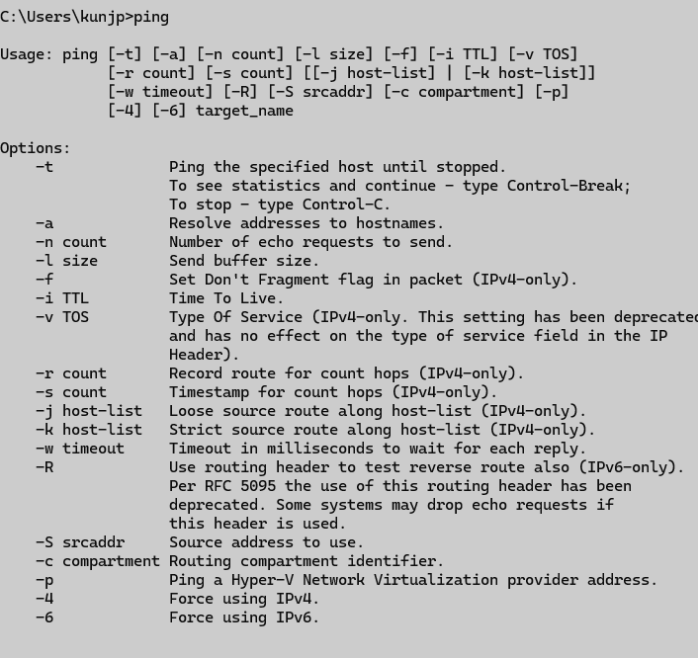

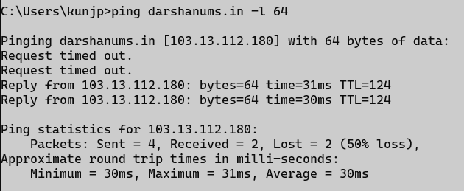

2. ipconfig/ ifconfig/ all / release /renew

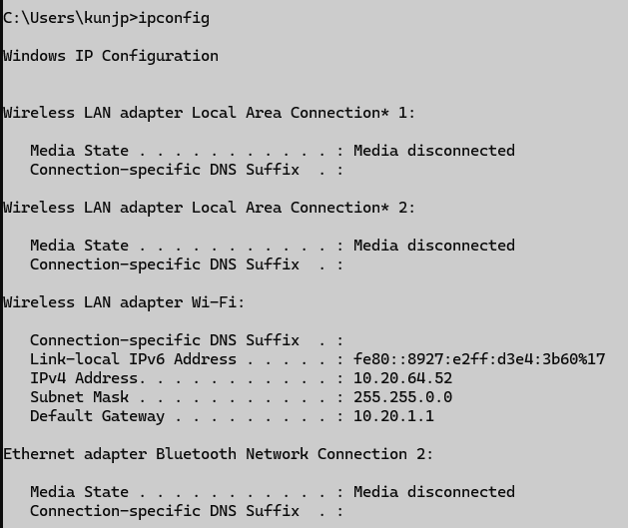

3. getmac

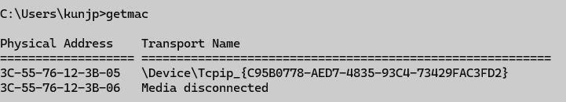

4. hostname



5. sysyteminfo /FO

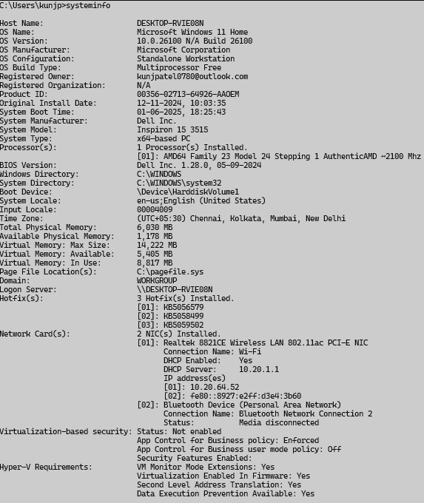

6. nslookup / nslookup [-opt...] - server, [-opt ...] host,

7. tracert / traceroute /-d,-h,-w

8. pathping /-h,-g,-I

9. netstat/-a,-b,-c

10. Arp/-a,-d,-s

Lab2 Write diff ------ 12/06/2025

Repeater and hub

Switch and hub

Switch and router

Router and hub

---------------------difference below--------------

**1. Repeater**

1. A repeater is a network device used to regenerate and amplify signals to extend the range of a network.
2. It operates at the **Physical Layer (Layer 1)** of the OSI model.
3. It is typically used in long-distance networking where signal degradation occurs over extended cable lengths.

**2. Hub**

1. A hub is a basic networking device that connects multiple computers in a LAN and broadcasts data to all connected devices.
2. It also operates at the **Physical Layer (Layer 1)** and does **not** filter or manage traffic.
3. Due to broadcasting, it can cause **network collisions** and reduced efficiency in larger networks.

**3. Switch**

1. A switch is a networking device that connects multiple devices in a LAN and forwards data only to the device for which the data is intended.
2. It works at the **Data Link Layer (Layer 2)** and uses **MAC addresses** to filter traffic.
3. Switches improve **network performance and security** by reducing unnecessary traffic and collisions.

**4. Router**

1. A router is a device that connects different networks together and determines the best path for data packets to travel using **IP addresses**.
2. It operates at the **Network Layer (Layer 3)** of the OSI model.
3. Routers enable **internet access**, manage traffic between LANs/WANs, and can include features like NAT, DHCP, and firewall protection.